Toothpaste and Its Effect on Bacteria

Oyinade Oyenusi and Hadley Saba
5204 Roland Avenue, Baltimore, MD 21210
Roland Park Country School
8th Grade
Table of Contents

Introduction Page 3

The Experiment Page 4-5

Discussion Page 6

Conclusion Page 7

Acknowledgements Page 8

References Page 9

Introduction

There are so many toothpastes, but which one works the best at preventing bacteria growth and cavities? Does toothpaste actually help to prevent the growth of bacteria in your mouth? These questions are what prompted our research. We hoped to find the toothpaste, out of three different brands, that prevented the most mold growth. Our hypothesis was that the bread with Close-Up Anticavity Fluoride Whitening Toothpaste Gel Cinnamon Red would produce the least amount of mold. By completing this experiment, what we hope to achieve is the knowledge of which toothpaste is actually working to ultimately stop tooth decay in our mouths.

The Experiment
The first thing that was done for this experiment was to find the brands of toothpaste and bread that were going to be used. Because of the variety in the different brands, it was eventually decided to use Colgate Fluoride Toothpaste Kids Cavity Protection Bubble Fruit Flavor, Ultrabrite Anticavity Fluoride Whitening Toothpaste with Baking Soda and Peroxide, and Close-Up Anticavity Fluoride Whitening Toothpaste Gel Cinnamon Red. Nature’s Own Whitewheat Bread was then chosen, because its color would make mold growth more noticeable than whole wheat bread.
Then it was time to actually conduct the experiment. Three slices of the bread were taken, and each slice was cut into two by two inch pieces. A total of nine of the two by two pieces of the bread were used, with three pieces of bread for each brand of toothpaste. Three graduated cylinders were taken, one for each different brand of toothpaste. In each graduated cylinder, 10 ML of that specific brand of toothpaste was mixed with 20 ML of water from the sink. Because people do not naturally brush their teeth without water, it was felt that it was important to mix it in with the toothpaste. A pipette was then taken, and 42 drops of the correct toothpaste and water mixture were put on each piece of bread. This bread was placed in a petri dish and left on the counter for a total of seven days.
After this, data had to be collected. On the days when there was school, observations were made of each piece of bread. The observations were made on what the bread looked like, whether the bread was still wet from the toothpaste mixture, if it had dried up, and if there were any signs of mold growth. Additionally, pictures were taken, so that the change in the bread could be seen over the one week time period, and so that they could be referred back to when the time to analyze the data came.
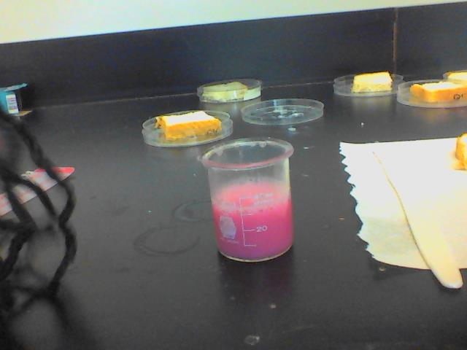
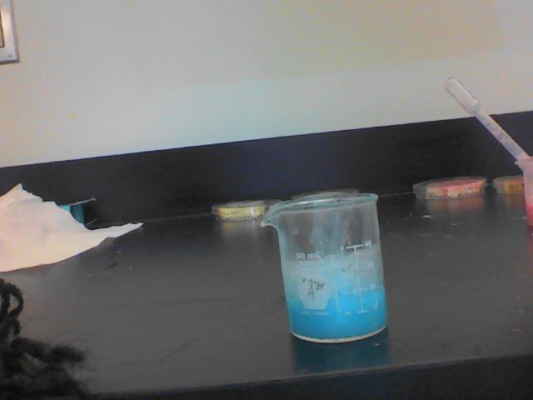
Colgate Fluoride Toothpaste Kids Cavity Protection Bubble Fruit Flavor and Water Mixture
Close-Up Anticavity Fluoride Whitening Toothpaste Gel Cinnamon Red and Water Mixture

Ultrabrite Anticavity Fluoride Whitening Toothpaste with Baking Soda and Peroxide and Water Mixture

Discussion
After the one week period, we concluded the results. Each piece of bread looked the same; no sign of mold. Although, the bread with the Colgate toothpaste and the bread with the Close-Up toothpaste were slightly darker than the Ultrabrite bread, there was still no sign of mold. Therefore, each toothpaste worked just as well as the other at preventing mold growth. We expected that the bread with the Close-Up toothpaste on it would prevent the most mold growth, but it did not turn out this way. The data did not vary in any way between the repeated observations of our three different trials. Our results may have been affected because on March 2, 2015 there was a snow day, and we were not able to observe the changes. However, this snow day did not change the fact that, at the end of the day, there was still no mold growth. If this project was to be repeated, we would have researched more about how to calculate mold growth, therefore possibly making our data quantitative. Other experiments that should be conducted are what mouthwashes work best at preventing bacteria, as well as if mints and/or gum reduce the production of bacteria in the mouth.

Conclusion
In conclusion, our hypothesis, that the Close-Up Anticavity Fluoride Whitening Toothpaste Gel Cinnamon Red would work best at reducing bacteria, was not proven. The results were the same for all three trials of the different brands of toothpaste. Each toothpaste was equally beneficial in making sure that no mold formed on the bread during the one week that it was sitting out. Therefore, although the toothpaste was able to prevent the growth of mold on the piece of bread, the Close-Up Anticavity Fluoride Whitening Toothpaste Gel Cinnamon Red could not be considered the best of the toothpastes for reducing bacteria, because there were no differences in the data for each toothpaste brand.

Acknowledgments
Thank you to Elisha James, our mentor for STEM, and to David Brock for helping us to better our procedure. In addition, thank you to Roland Park Country School for supplying us with our materials and giving us space to complete our experiment.

References
American Dental Association. N.p., n.d. Web. 23 Feb. 2015. <http://www.ada.org/en/science-research/ada-seal-of-acceptance/product-category-information/toothpaste>.
Brock, David. Personal interview. N.d.
Centers for Disease Control and Prevention. N.p., n.d. Web. 23 Feb. 2015. <http://www.cdc.gov/mold/faqs.htm>.

